Applicant Response Form – FOR FURTHER ITERATION

SECTION 1: Overview
Applicant Information

Country | Bangladesh
Applicant Type | CCM | Component | HIV/AIDS
Envisioned grant(s) start date | 01 December 2020 | Envisioned grant(s) end date | 31 December 2023
Principal Recipient 1 | Ministry of Health | Principal Recipient 2 | Save the Children International
Principal Recipient 3 | icddr, b | Principal Recipient 4 | N/A

SECTION 2: Approach to Funding Request Revision
The applicant is requested to provide a summary of the steps taken to revise the funding request. This could include engagement of stakeholders to discuss program weaknesses, steps to improve data, engagement of in-country technical experts, involvement of key populations, etc.
Please provide an executive summary of the actions taken:
On June 22, 2020, the Global Fund informed Bangladesh that as per a rigorous review of the proposed HIV programme, the Global Fund’s Technical Review Panel (TRP) has recommended further iteration of the HIV funding request before proceeding to grant-making. In its recommendations, the TRP raised issues for further consideration and actions that should be addressed by the Bangladesh CCM to revise the funding request to be more technically sound and strategically focused for maximum impact.
Upon receiving this information, the AIDS/STD Programme (ASP) organized a meeting among the major stakeholders linked to the national HIV response on June 25, 2020 which included NGO and UN Partners, the BCCM Coordinator and the national consultants engaged in preparing the Global Fund funding request proposal and revising the National Strategic Plan. During discussions it was agreed that:
- a seven-member writing team would be engaged immediately consisting of representatives from the three Principal Recipients, UNAIDS, UNICEF, UNODC and the ASP as the Chair. The writing team would initially draft responses to the six issues raised by the TRP
- UNAIDS would arrange to engage an international consultant for the overall review and finalization of the funding request (FR) and the drafted TRP responses.
- A draft roadmap would be developed for proposal re-submission.
- A meeting of the HIV Technical Working Group (TWG) of the BCCM would be arranged.
- Oversight committee of BCCM meeting was held on 9 August 2020 to discuss an overall update of the funding request preparation and response to the TRP recommendations
- A BCCM meeting was held on 16 August 2020 to provide the members with an update of the funding request preparation and response to the TRP recommendations
The seven-member writing team met on July 02, 2020 to discuss the TRP issues so they could start drafting a response. It was proposed that the team would aim to submit the revised FR by July 30, 2020, depending on progress made.
On July 8, 2020, the 32nd Meeting of the HIV TWG of the BCCM was held to discuss the TRP response and resubmission plan of Concept Note to Global Fund for the next funding cycle 2021-2023, along with other agenda items. The TWG agreed to the Road Map, bearing that the submission should preferably be by August 31, 2020; the composition of the seven-member writing team was agreed, as well as the engagement of an international consultant.
As per the Road Map, ASP organized a consultation meeting with Key Population (KP) Networks on July 14, 2020 to gather their feedback on how to address the issues raised by the TRP. The feedback received was as follows:
- The target coverage of all KPs should be increased, especially that of PWID, the most HIV affected population; the target should be at least 90%;
- There is a need to find alternatives to the DIC based intervention, as this approach is not cost-effective. Cheaper approaches for HIV service delivery should be carefully tested in the form of pilot projects. Some also mentioned that the DIC is a very friendly environment which they could access without fear and discrimination, whereas the government hospitals may not have the same environment. DIC remain necessary for the most vulnerable KP;
- The program needs to be innovative and strategic so we can reach our 90- 90-90 targets;
- Community development should be emphasized as a strategy for long-term sustainability;
- In terms of HIV services for Rohingya refugees, there is a need to strengthen networking with existing program implementation partners, as there is no scope for additional funding within the coming allocation;
- A comprehensive plan to develop a national training curriculum for police/law enforcement agencies focusing on PWID and hijra communities is needed;
- This should go hand in hand with the development of national guidelines on dealing with KP for newly employed government officials especially under law enforcement, addressing steps towards sensitization towards KP communities so they are protected, rather than discriminated against;
- To address loss-to-follow-up from ART, PLHIV representatives suggested that local self-help groups could be formed, a digitalized profile/mother-list should be used which would include the NID, a voucher schemes might help prevent loss to follow up cases, as may a door-to-door Peer Navigator mechanism to track clients;
- Community representatives should be more involved in KP interventions, especially in monitoring and improving the quality;
- A standard salary should be agreed for outreach workers across the program;
- A Training Needs Assessment (TNA) should be conducted to inform a comprehensive capacity building plan;
- Local and larger offices of the self-help groups may play an active role in client’s/patient’s referral linkages with the government hospital;
- Mental Health, including psycho-social support should be a major component of HIV interventions, especially for PLHIV;
- Engaging the Networks in higher level advocacy meetings is important;
- CBO collaboration with GOB needs to be better emphasized.
After this consultation, the next meeting of the Writing Team was held on July 22, 2020 to discuss the progress on the Road Map. At that meeting it was decided that Bangladesh would submit the revised FR on August 31, 2020. Following this update, the draft TRP responses were further develop by the Writing Team and then sent to the Global Fund Country Team (GFCT) on July 31, 2020 along with the revised budget, Performance Framework (PF) and List of Health Products (LOHP). By August 5, 2020, the international consultant was on board and the Writing Team and the Consultant took part in the face to face discussion with the GFCT from August 11 to 13 to discuss the TRP responses and how best to strategically position the interventions in the revised FR.
Based on the detail discussions with the TWG, the Networks, the GFCT and constant consultations within the Writing team along with the Consultant, the revised FR and TRP responses were finalized and the budget, PF and LOHP were updated.

SECTION 3: How technical issues have been addressed
This section includes a pre-filled list of the technical issues identified by the TRP in the initially submitted funding request (Sections 4 of the Review and Recommendation Form). The applicant is requested to provide a brief explanation of how each TRP input and requested action has been addressed in the revised funding request.

Issue 1: Inadequate description of the strategies to address gaps in the prevention and treatment cascades to ensure a more rapid progress towards 90-90-90
TRP Input and Requested Actions
Issue: Between 2010 and 2019, the HIV incidence in Bangladesh increased by 56% and mortality increased by 110% clearly demonstrating quality issues with the program. This conclusion is in line with epidemiological and programmatic data presented in the funding request, which clearly showed gaps in the HIV treatment cascade. As of 2019, only 52% of the estimated 14,000 people living with HIV (PLHIV) were aware of their status, of whom 54% were on ART representing 28.6% of the estimated total population of PLHIV in the country. Of the 4,009 PLHIV on ART, only 14% (522/4,009) had viral load testing, of whom 85% were virally suppressed.

While the TRP recognizes the efforts made by the country to address the gaps in the 90-90-90 treatment cascade among KP and their clients, including some differentiation of HIV testing services (i.e. community based-testing, task-shifting to lay providers among others, and scaling ART and viral load services), the funding request did not adequately describe how the activities listed will be conducted and coordinated to achieve the desired targets especially at the facility and community levels. For example, the funding request proposes to close some comprehensive drop-in centres (DICs) and to create sub-DICs, outlets and satellite centres with more limited services but failed to describe a strategy for linking these peripheral services to the sub-DICs and comprehensive DICs to ensure maintenance of adequate coverage and quality of services.

Furthermore, the targets identified in the funding request were low and therefore unlikely to help the country to achieve the targets of the 4th Health Population Nutrition Sector Program (HPNSP) 2017-2022, which aims to contain HIV transmission and minimize its impact to end AIDS by 2030. For example, even though the major driver of HIV in Bangladesh is PWIDs, the funding request proposes to increase service coverage for PWIDs by only 12.4% by the end of the grant (from 28.7% to 41.1%), increase OST coverage by 4.3%, other prevention services by 6.8%, and HTS by 1.8%. For treatment, care and support, an additional 436 PWIDs are proposed to be reached over 3 years bringing the total PWIDs covered by treatment, care and support to 1160. The TRP therefore remains concerned that the proposed prevention and treatment coverage targets, as per the performance framework, are not ambitious enough to achieve the necessary progress toward achieving HIV disease control by 2030.

Despite the proposed progressive introduction of viral load testing capacity in government facilities, only 14% of HIV patients receiving ART had a viral load test. The funding request does not provide adequate description of how viral load testing will be significantly increased to bridge this gap. The TRP is also concerned that the funding request does not adequately describe interventions to ensure retention in care and which intervention are targeted to patients with high viral load. The Funding Request insufficiently addresses how the listed barriers and inequalities in KPs’ ability to access facility-based services, including need to access services outside normal working hours, privacy and confidentiality will be removed or addressed. (See also Issue 4)

Action: In the revised funding request, the TRP requests the applicant to clearly describe how the proposed interventions will be conducted and coordinated to address gaps in the prevention and treatment cascades towards achieving the target of ending AIDS by 2030. The funding request should:

1) Include a clear description of strategies for differentiated HIV testing for the different key populations, explaining how these strategies will be prioritized and operationalized, through evidence-based interventions including index-case testing, couple testing and self-testing at facility and community level. The applicant should consider weighing and selecting strategies to aim for scale-up and maximise the identification of people living with HIV, i.e. index-case testing, couple testing and self-testing.

2) Define a clear linkage to care process from testing to treatment initiation and retention, including how the satellites and outlets will link to the Drop in Centres (DICs) and sub-DICs, and how “one-stop-services" will be scaled at each level of care to ensure retention in care, minimize loss to follow-up and adequate coverage and quality of service.

3) Ensure that differentiated treatment services are taken to scale and prevention and treatment targets are revised accordingly toward achieving the 90-90-90 targets, including key population friendly services, enhanced adherence support to ensure retention and re-engagement for those who are lost to follow up, multi-month ART prescription, peer-to-peer support, TB/HIV service integration.

4) Include plans to improve viral load monitoring, including routine management of patients with high viral loads and provide assurance that viral load testing strategy and justification of Gene Xpert deployment plans are aligned with the needs of the KPs.

5) Ensure that funding for differentiated HIV testing strategies, especially for people who inject drugs is commensurate with the ambition to find 90% of those who are not aware of their HIV status.

TRP response of Issue 1
Action 1:
Improving HIV case finding is a top priority in the revised funding request. Following WHO guidelines, creating different options for HIV testing will increase demand and access to HIV testing, and hence increase the number of previously undiagnosed PLHIV in Bangladesh. This is because the different modalities are likely to appeal to and provide easier access to different (additional) sub-groups of the key populations.
Diverse approaches for generating demand for HIV testing are in place, e.g. via outreach and BCC materials. Phone communications, text and voice SMS, and HIV self-risk assessment through mobile and web-based applications (including linkages to HTS facilities) are in place, particularly for MSM and hijra. Transportation costs to visit HTS centers are being provided to encourage uptake of testing. Counsellors/medical assistants and DIC manager/in-charge motivate KP through counselling and group education sessions, primarily in service delivery points, though they also occasionally provide home-based and family counselling. Existing approaches for demand creation will be continued and intensified. Community-based organizations (CBOs), self-help groups and community networks (SWNoB, NPUD) will also be engaged to help foster KP mobilization (including their clients) and create demand for HTS.

The following seven differentiated HIV testing strategies will be promoted and employed during the next grant:

- Facility-based HIV testing services

Prioritization: Facility-based (HTS) has been provided via 103 NGO service centers and 28 Govt. HTS centers. This is a preferred modality among all KP due to familiarity and the perception that DIC is a “safe space” where privacy and confidentiality are ensured. Moreover, these NGO operated facilitates can also efficiently and conveniently establish linkages to care. In contrast, GoB operated HTS centers are servicing the general population, though KP can also be tested there. In order to create a KP friendly environment at GoB facilities, ASP will work on sensitization, orientation and training of GoB service providers with the help of the other 2 PRs. The aim is that GoB HTS facilities become KP-friendly and can that they also provide services to KP. NGO HTS service providers will also be trained periodically, especially if and when national HTS guidelines are updated.

For KP, outreach staff [peer educators (PEs)/ outreach workers (OWs)] motivate and refer KP for facility-based service uptake through BCC sessions or ICT approach. Moreover, many KP access facility-based HTS without referral. By 2023, the GoB plans to expand HTS centres to all 64 districts, i.e. an additional 36 HTS centres will be established using government funding.

In the current grant, trained MA/MT of the respective HTS centers provide HTS following standard procedures (i.e., consent, pre-test information, HIV testing and post-test counseling) while maintaining privacy and confidentiality. As per the national HIV testing algorithm, the WHO-recommended HIV rapid testing approach will be followed, where whole blood is collected by finger stick and three rapid tests are performed. Oral fluid-based self-testing will also be available for those who refuse to partake in blood-based testing (detailed in the self-testing section). All clients will receive their test results through post-test counseling on the same day of testing.

- Community-based HTS

Prioritization: Community-based HTS can conveniently reach most KPs with impeded access to facility-based testing, especially MSM, male clients of FSW, street-based PWID and some hijra. Community-based HTS is currently available at convenient community-based locations and settings (i.e., residences of hijra guru or influential community members; hotels, residences and congregation sites for FSWs, drug spots frequented by PWID, etc.), following the standard procedures of HTS.

This includes targeted HIV testing campaigns focusing on key populations that will periodically be organized at comprehensive Drop In Centres (CDIC) as well as Sub-DICs and Outlets, congregation spots and other public gathering spots (e.g., bus terminals, ferry terminals (ghats), big markets (Bazars), etc. to maximize HTS coverage and also to reach key populations who generally do not visit such service centres. Community leaders will be enlisted to help in these efforts. Demand-based HTS sessions and satellite HTS sessions will be conducted during weekends/holidays for full-time working beneficiaries and remote populations, respectively, after assessing the demand and prior mapping exercises.

KP will be informed about HTS session schedules by the PEs/OWs beforehand. KP will attend the session for HTS through peer referral or self-referral and receive HTS following a similar format to facility-based HTS.

- Provider-assisted referral (also called index testing or assisted partner notification)

Prioritization: Despite differing contexts for each KP, Index testing is equally crucial for all KPs. HIV Index testing involves providing HTS to family members of known PLHIV (index clients). It will be offered to spouses, biological children, and regular partners. This approach will not only increase identification of previously undiagnosed HIV cases, but also increase linkage to care and treatment services. HTS service providers will be trained on index testing strategies (including partner counseling and linkage strategy) by the respective PRs during HTS training to properly implement this strategy.

Currently, the trained service providers (i.e., MAs/MTs/Lay provider) directly assist all PLHIV (index clients) by reaching out to their sexual and/or drug injecting partner(s) from the past year, as well as spouses and biological children. If the index client provides their consent, each listed spouse, partner, and child are contacted, informed of their HIV exposure, and offered HTS, upholding the conventions of social and cultural sensitivity. This approach will be enhanced in the next grant and conducted either at service centers, community settings or through referral to Govt. HTS centers.

HIV rapid testing approach will be used, following the national HIV testing algorithm. Moreover, self-testing method will also be considered for index-testing or partner notification (detailed in the “self-testing” section). The case management team will link positive index cases to the ART centers for treatment, care, and support services. Index testing will be consensual, confidential, and include counseling, correct test results, and connections to prevention and treatment. A set of tools will be used for data collection and reporting.
.
- Social network-based approaches

Prioritization: This approach is more suitable for MSM, hijra and FSW and their sexual partners, who maintain extensive social and sexual networks. This approach can also apply to PWID and their injecting networks. This approach could be effective in situations where KPs are reluctant to uptake provider-assisted referral out of fear of identity disclosure or stigmatization/ discrimination/prosecution.

WHO guidance suggests that untested KP are more likely to ascent to HIV testing if a trusted member of their social network suggests it. Social network-based HIV testing approaches are an extension of HIV partner service. Based on network analysis, trained service providers (i.e., MAs/MTs/lay providers) will ask KP (HIV+ and HIV- alike) to encourage and invite individuals within their social contact networks in addition to their sexual and/or drug-injecting partners at risk of HIV to come forward and access HTS of their preferred modality. Various strategies will be used to enhance this approach such as engaging peer educators and navigators, and outreach workers and fostering self-referral through referral coupons. Participants undertaking social network based HTS will receive a monetary incentive in the form of conveyance allowance. This approach will also be linked with HIV self-testing services as HIV positive and negative clients may distribute HIV self-testing kits to their partners and contacts.

- Self-testing (HIVST)

Prioritization: HIVST can be provided to all KP since it is possible to distribute through diverse channels, and is complementary to other HTS models. This can help optimize coverage for obscure populations, such as unreached KP and sexual partners of KP. It can also be a convenient and safe tool to access HTS during the COVID-19 era.

An operational research study on self-testing among MSM and hijra is ongoing in the current grant, which will end by 2020. If the study finds that there is demand among MSM and hijra that may add value to the HIV response and possibly reach KP who would otherwise remain untested, HIVST will be added to the comprehensive package of HIV services for MSM and hijra.

Meanwhile, guided self-testing will be piloted for 1000 FSW and their partners. FSW reached through virtual spaces will be offered anonymous self-testing. To reach adult women who may suspect their husbands to be MSM, PWID or clients of FSW and who might be interested in HIVST, PR-SC will create a Facebook page with online IEC/BCC. Potential clients will be able to contact the project via inbox messaging, and risk behaviours will be analysed; if there is significant HIV risk they will be referred and connected to an outreach worker through confidential one-to-one channels for follow-up HIV testing, STI management, condom promotion, and other required services.

For 500 PWID and their partners and family members, guided self-testing will also be piloted during the coming grant.

As per the national HIV testing algorithm, all the positive self-testing results will be confirmed by three HIV rapid tests. If any KP/ partner would test positive, he/she will be referred for a confirmatory test at the respective service centers (for male/hijra partners) or GoB operated HTS/ART centers (for female partners) through the support and supervision of MA and case management staff.

HIV self-testing that has already been included in national HTS guideline will be further elaborated based on the findings from the operational research for wider implementation among KPs. A set of data collection and reporting tools and will be developed to facilitate client tracking and monitoring.

- Lay provider HIV testing

Prioritization: Lay providers with the same risk exposure or socio-cultural bracket of KP can significantly increase enrolment into HTS, contingent on adequate training and competent supervision. Lay-provider testing is therefore a task-shifting and cost-effective method for KP who are reluctant to uptake facility-based services or find HTS schedules inconvenient.

Besides the facility-based approach, Bangladesh has phased in a community-based approach for PWID and FSW either by lay providers or community health workers who are trained and supervised to administer rapid diagnostic tests. Community based HTS by lay providers will be continued into outreach modalities for KP. These services will be directly linked to facility-based HIV testing sites which can provide a confirmatory HIV diagnosis in case of a reactive screen-test result.

- Couple testing

Prioritization: Partner or couple-based HIV testing and counseling can foster additional support and safe disclosure. It can also increase willingness to uptake HTS if one member of the partnership is already availing HTS and knows their HIV status.

The provider (MA/MT) will counsel the couples together, test both of them and receive their results together, upon receiving consent from both parties. Couple testing services will be confidential. They should unanimously decide whom they can disclose their results with. Appropriate and high-quality pre-test information and post-test counseling will be ensured, including the provision of effective referrals to appropriate follow-up services such as long-term prevention and treatment support. Prevention, treatment and care decisions can be made together, as well as decisions about family or child testing, and family planning. Quality assurance mechanisms and supportive supervision systems will be in place to ensure the provision of high-quality counseling to couples and partners.

There are some possible barriers/implementation challenges of differentiated HTS that are listed below:
- Challenges impeding HTS uptake by MSM and hijra populations include fear of blood tests, social stigma attached to male to male sex and HIV, and fear of negative social implications if tested HIV positive. FSWs also feared being tested positive, which they perceived would affect their sex work through both losing clients if their HIV status is known, and also through losing sexual energy after giving their blood sample. Though access and utilization of HIV testing among PWID has increased over the years, stigma, criminalization and human rights violations still deterred HTS uptake.
- Status disclosure of parents and testing children remains a challenge in index testing due to fear of potential emotional trauma. Moreover, many women fear gender-based violence, intimate partner violence, loss of relationship or other adversities due to status disclosure.
- Clients may perceive oral fluid based self-testing less reliable compared to conventional blood-based testing. MA may perceive the follow-up process as an additional burden. It is also challenging to ensure consent for partner testing and to bring positive cases (partners) for a confirmatory test.
- It will be a challenge to appropriately select suitable lay providers for the people they serve. Clients may raise issues of confidentiality as their sero-status may be disclosed around the community. Lack of accredited training curriculum for lay providers and lack of structured system for remuneration and recognition for lay providers’ services are potential implementation challenges.
- Providing HIV testing for negative partners within sero-discordant relationships will be a challenge.
Some strategies are planned for the upcoming grant to overcome the possible barriers/ implementation challenges of differentiated HTS:
- Demand creation and awareness raising strategies for HTS which have been described above;
- The capacity of counselors providing services to HTS clients will be strengthened, focusing mostly on higher standards for client privacy and confidentiality.
- Coordination with relevant stakeholders and PLHIV networks will be improved, in order to create a friendly and accessible environment at the facility and community, free of stigma and discrimination.
- Training and capacity building will be continued for HTS providers to deliver high quality counseling and minimize mistrust, conflict and violence between partners. To improve service delivery, monitoring and evaluation will be in place.
- For index testing, the case management team will conduct home visits (if required) and provide intensive counseling (including family counseling). Index client and their partner will be prioritized. Positive couples will also have linkage provisions to family planning and childcare services.
- Instruction leaflets and videos on HIV self-testing will be developed in the local language, that are user-friendly, visually attractive and contain clearly understandable instructions and information. Self-testing will be advertised and disseminated to build trust among users. Structured follow-up and linkage mechanism will be established for confirmatory testing and linkages to care.
- Standard selection criteria will be followed to recruit lay providers as per the national guideline. A system for quality assurance, including external quality assessment, will be adopted for HTS provided by trained lay providers. The HTS by lay provider approach will be closely monitored and supervised. Based on local contexts and population dynamics, a training manual will be developed for lay providers.

Young and adolescent KP are deterred from accessing HTS by social stigma, fear of identity disclosure to older KP and the general population, low risk perception, and inconvenient testing schedules. MoHFW of Bangladesh issued a Circular to provide prevention interventions, including HTS, for vulnerable adolescents and young KP without needing consent from their legal guardian. PRs will employ several focused initiatives to cover young KP. In particular, initiatives will be taken such as recruiting young and adolescent PEs/POWs at every service delivery point, engaging young CBO members for community mobilization, increasing awareness among young KP about HTS, using ICT platforms, introducing youth-friendly testing schedules, (i.e. weekends and beyond conventional office hours), making counselling services youth-friendly, staff capacity building (orientation/training), arranging differentiated HIV testing strategies including HIVST, satellite HTS session at preferred venues, e.g. at dera, youth clubs, other comfortable locations, etc.. In addition, group education sessions will be arranged with MARA and youth KP to increase HIV testing.
Action 2: Define a clear linkage to care process from testing to treatment initiation and retention, including how the satellites and outlets will link to the Drop-in Centres (DICs) and sub-DICs, and how “one-stop-services" will be scaled at each level of care to ensure retention in care, minimize loss to follow-up and adequate coverage and quality of service.
Client linkage to ART initiation: Clients who show a reactive screen-test are referred to HTS facilities for immediate confirmation testing (if the screen test is done in the evening, this may need to be a day or two later). The program will prioritize linkages to ART centres / CDICs preferably on the same day a HIV test result is confirmed as positive. ART will be initiated as soon as the patient is ready, preferably within a 7-day window. ‘Community Peer Counselors (CPC)’ will be the key actors of patient navigation or case management, following a recent study that found they were successful in improving enrolment and adherence among a cohort of PWID PLHIV [26]. To facilitate linkage from testing to treatment and avoid loss-to-follow-up, various activities have been built in to the program: i) accompanied referral with conveyance allowance support; ii) ensuring baseline testing; iii) booking appointment with ART physicians; and iv) ensuring prompt treatment enrolment. Similar services at the same facilities (if possible) will also be available for HIV positive partners/spouses/children of PLHIV. Programmatic experiences indicate that these selected linkage and case management activities improved enrolment and adherence outcomes. ART retention among MSM and TGW increased from 47.7% to 86.2% since the case management program started in 2018; the remaining 13.8% were, for various reasons, not ready to start, but were in touch with peer navigators (PNs); no case was lost to follow-up since the case management program started. No data is available on how many of them were linked to ART within a week.

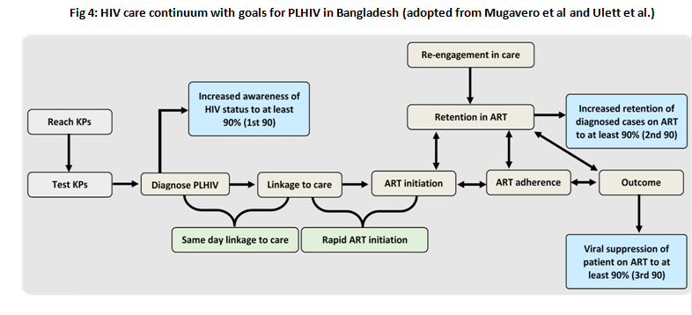
Fig 1: HIV care continuum with goals for PLHIV in Bangladesh

Despite the positive outcomes of the case management program, several challenges remain. Firstly, due to limited number of ART centers, PLHIV often have to travel long distances for consultation and medication. Given their poor financial circumstances and lack of stable housing, they cannot afford travel and base line diagnosis costs. Secondly, PLHIV refrain from HIV status disclosure due to anticipatory fear of multifaceted stigma, discrimination and exclusion from service providers and the mainstream community. It was also challenging to find available physicians in the ART centers who were adequately motivated to provide ART services to PLHIV. Thirdly, PLHIV were often lost to follow up in absence of adequate adherence support. Many PLHIV suffer from co and multi morbidity, forgetfulness, depression, anxiety and other mental health problems. ARV side effects and inadequate nutritional support have also hindered ART retention. Fourthly, capacity of PN/POW/CPC is a constant issue that will be enhanced through several capacity enhancement initiatives and supportive supervision. Fifth, tracking lost to follow up cases and monitoring progress of PLHIV has been a challenge. Lastly, miscellaneous issues including lack of appropriate environment for counselling services at service delivery points, and mismatch of ART office hours with clients’ personal schedules served as retention barriers. Besides, inadequate capacity and knowledge of ART among service providers to work with PLHIV and lack of protection of privacy and personal information posed as challenges. In the above and subsequent paragraphs, we elaborated the strategies to address these challenges.

Clients retention in ART care: Case management staff assigned to PLHIV will coordinate their tasks with the MA of respective service centres to ensure linkage, follow-up and retention within care, by maintaining PLHIV confidentiality and privacy. Under the counsellor’s supervision, case management staff (PN/POW/CPC) will conduct one-to-one and group education sessions for treatment literacy, and provide ART adherence counselling both in-person and over phone. Nutritional support will be available for PLHIV and monthly adherence support will be provided for PLHIV and their family members. The linkage and subsequent ART prescriptions will be followed up so that any loss to follow up (LTFU) cases will be notified early. ART coverage for PWID will be revised/increased from 1160 to 1,238 (see Performance Framework). They will attempt to situate missing clients and bring them back under care with continuous motivational and psychosocial support to maintain adherence. Case management staff will remain in close contact with the PLHIV and remind them of their appointments for ART refill and/or clinical/psychosocial consultation and provide ART stock reminder phone calls to ensure uninterrupted ART support. Stable clients will refill their ART from outlets to reduce loss-to-follow up and improve adherence.

Capacity building and co-ordination initiatives: Training programs will be organized by ASP and other PRs for both case management staff and public health service providers either centrally or at ART distribution points to provide differentiated HIV treatment services within a KP friendly environment without discrimination. Quarterly or biannual coordination meetings will be organized with all relevant stakeholders involved in the treatment and care process to analyse the barriers to care, remove bottlenecks and strengthen coordination to facilitate linkage to and retention in care. Throughout all steps, community members such as people in the PLHIV network will be closely engaged and their feedback will be considered.

Linkages between community based services: HIV prevention services for MSM/MSW and hijra have been operating through various service centre modalities such as DICs, sub-DICs, outlets, and satellites (see Fig. 2) since December 2015. Outlet and satellite services will be directly linked to, operated by, and reported through the respective DIC/sub-DIC where the DIC manager and Sub-DIC In-Charge will oversee the implementation and quality of the activities. Regular communication with beneficiaries will ensure that loss-to-follow-up is avoided.

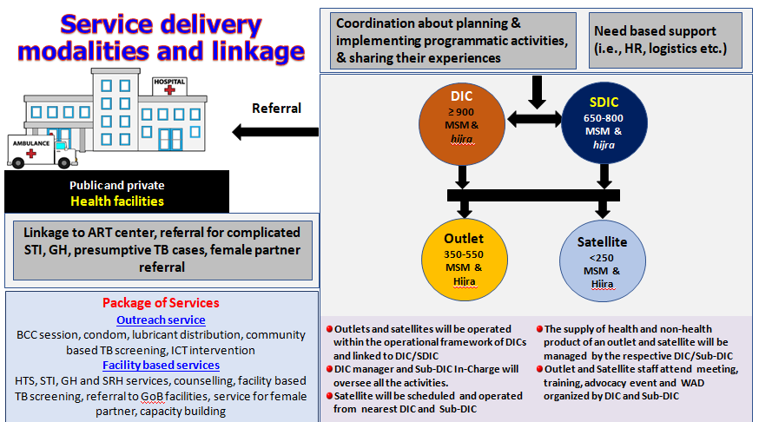

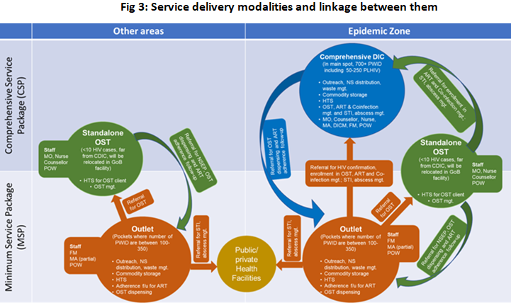
In epidemic districts, “one-stop-service” from comprehensive DICs (called as CDIC) will be offered to PWID. There will be outlets in distant pockets of epi-districts, from where a minimum package (e.g. Outreach, NSEP, waste disposal, commodity storage, HTS, OST dispensing and ART adherence support) of services will be offered and will be linked either with CDIC, OST centre or public/private hospitals for HTS; ART, OST, STI and abscess management. In other districts, outlets will offer a minimum package, with strong linkages to public hospitals for clinical services and OST centres for OST. Each layer of service centres will provide all prevention services to enlisted PWID and will be scaled for reaching out to remote pockets to provide services to as many PWID as possible. The below diagram (Fig-3) shows the linkages between the different service delivery points and differential service delivery for the PWID considering epidemic zone and other priority districts.

For FSW, a minimum service package of BCC, condoms and HTS will be ensured from outlets. Around 10% of FSWs will be referred annually to public hospitals for HTS. Outlets will also refer a gradually increasing number of FSW to public/private hospital services, from 25% in year one to 45% in year three for clinical services including STI and ART for HIV positive cases. The rest will receive services at NGO-operated facilities. In the most vulnerable districts (i.e. Dhaka, Gazipur, Narayangonj, Chattogram, Cox’s Bazar, Khulna and Sylhet), FSW will be offered an intensive package package of services, consisting of BCC, condoms, HTS, STI diagnosis and treatment, SRH, TB screening, customized services for adolescent FSWs and harm reduction services for WWID engaging in sex work from DIC, where outlets will be the extensions of DIC to cover more distant pockets (Fig-4). Outlets and DIC will also operate satellite sessions in various spots/congregation areas for condom provision, HTS and STI management.

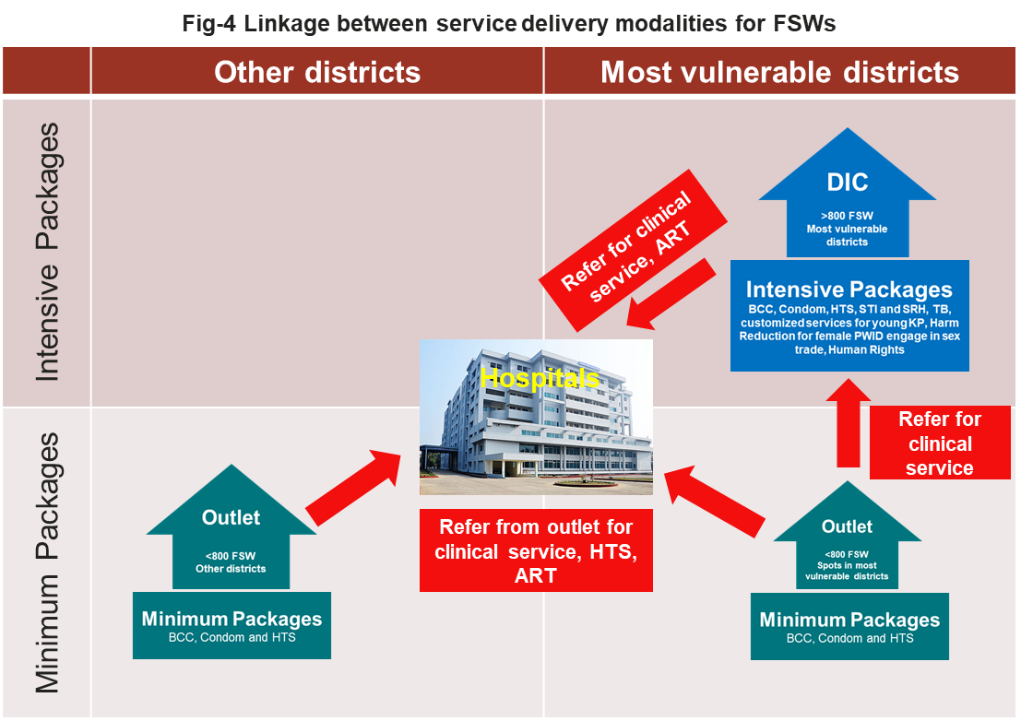

Quality of care: To ensure quality of care, PLHIV coordinators/peer navigators for respective KP will oversee treatment, care and support. For quality of prevention services, DIC manager/Sub-DIC In-Charge /Outreach Supervisor will physically visit cruising spots and the service centres periodically, generate visit reports and submit these reports to the PR and SR. PR and SR staff will also visit those service centres and check the service quality.

Action 3: Ensure that differentiated treatment services are taken to scale and prevention and treatment targets are revised accordingly toward achieving the 90-90-90 targets, including key population friendly services, enhanced adherence support to ensure retention and re-engagement for those who are lost to follow up, multi-month ART prescription, peer-to-peer support, TB/HIV service integration.

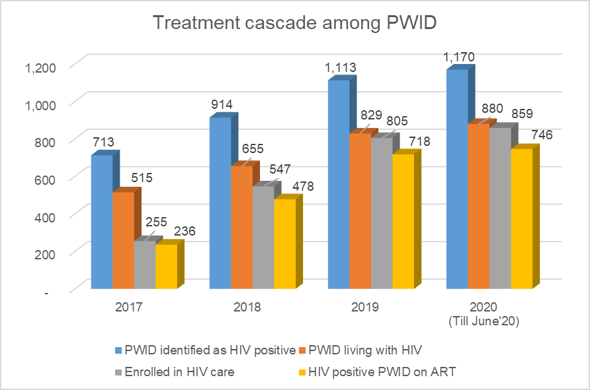
To achieve the 90-90-90 targets and advance towards ending AIDS by 2030, prevention and treatment targets will be adjusted accordingly. For instance, PWID prevention coverage increased from 9,500 to 17,035 and OST coverage increased from 2,800 to 3,500 from the current grant. Among the targeted PWID and FSWs, HTS coverage will be 90% as before and for MSM and hijra covered by HIV prevention services will be increased from 75% to 90%. Among PWID, case identification to retention in ART has increased substantially (see the graph NEEDS UPDATING).

Budgetary allocation is also considered for HTS coverage among KP and other populations. Moreover, regarding HIV treatment as of 2019, 52.7% of the estimated 14,000 PLHIV were aware of their status, of whom 54.4% are on ART representing 28.6% of the estimated population of PLHIV in the country.

Existing government-operated ART centres and HTS centres will continue to provide services for initial scale-up at priority districts. To expand differentiate treatment options, ART refill centres will be established, following the successful model of community-located ART centres. Case management initiatives for PLHIV via PNs/POW/CPCs recruited from the respective KP communities will be strengthened (see above). Clients with stable ART intake who are living in remote locations will be provided with multi-month ART. Peer-to-peer support among PLHIV will be encouraged by setting up informal support groups, partly virtual. Viral load monitoring services will be provided from ART centres to sustain a 90% viral suppression rate.

ASP and stakeholders will develop a Standard Operating Procedure (SOP) covering CD4 testing, viral load optimization, multi-month ART prescription for stable cases, care of non-viral load suppressed cases, etc. The national PLHIV database to track and follow up PLHIV will be strengthened to improve adherence and viral suppression data. ASP taken initiative to update and maintenance of PLHIV data base under this grant. In this context, ASP recently appointed new counsellors and MT lab staff in each ART centre. In year one, 3 ART centres will be piloted and gradually increased to 10 centres by the end of the period. ART retention will be considered a quality indicator, which will be included in the PF.

TB-HIV service integration: A strong collaborative link will be established between ASP and the DOTS centre of the TB programme. Service providers of the HIV program will be trained on TB-related services to capacitate them to administer TB-related services. Similarly, some providers from the TB programme will be trained on issues pertaining to HIV screening. National Tuberculosis Programme (NTP) and its partners (PR, SR) will be coordinated for better implementation of these activities at the district levels and below. An indicator will be included in the PF to assess the progress of TB/HIV related activity.

ASP will ensure HIV testing among people with TB through DOTS centres by supplying HIV test kits (from GF budget) and relevant training of the staff and through 28 HTS centres. 21-41% of the newly diagnosed TB and relapse TB cases will be tested under this grant. Each year, approximately 292,000 TB cases are diagnosed in the country, of whom 20.5% is targeted in year 1 for HIV testing, which will gradually be increased. PLHIV who have symptoms of TB, will be screened for TB using GeneXpert technology. Detected TB cases among KP and PLHIV will be linked with the DOTS centre. Further TB treatment follow-up and routine linkages will be performed by DOTS centre and POW at the CDIC/outlet levels. Quarterly coordination meetings will be organized between the stakeholders representing both disease components for better coordination and planning, and optimal utilization of resources. NTP has recently been supporting drugs and capacity building initiatives for initiation of Isoniazid preventive therapy (IPT) for PLHIV who are not TB positive, which will be expanded to all ART centres. NTP has procured and supplied GeneXpert machines across the country, thus also ensuring its availability at all ART centres. To reduce stigma and discrimination towards TB and HIV, ASP has been facilitating campaign programs through mass media including electronic and print under OP fund which will continue till 2023. TB-L and ASP Operational Plan is organizing seminars and workshop at different levels under 4th OP, where both diseases are discussed with participants.
Facility-based verbal TB screening will be continued for clinical services at CDIC/DIC/Sub-DIC/Outlet for KP. Community-based verbal TB screening will also be introduced through PEs. The presumptive TB cases will be linked through accompanied referrals to the TB clinics for further testing and treatment.

Action 4: Include plans to improve viral load monitoring, including routine management of patients with high viral loads and provide assurance that viral load testing strategy and justification of Gene Xpert deployment plans are aligned with the needs of The KP.

Under the national ART guidelines, each (100%) PLHIV need to be tested for viral load at the baseline, 6 and 12 months after the initiation of ART, and on a yearly basis to follow-up the treatment and early detection of treatment failure. PN/POW/ CPC will ensure that the viral test is conducted for all PLHIV at the recommended time through the accompanied referral system. In the event that any PLHIV has a high viral load (>1000 copies/ml), they will be followed up with a repeat viral load test, evaluated for non-adherence, and an ARV drug resistance test will be performed if indicated (subject to availability). Based on the report of the ARV drug resistance test, the necessary treatment regimen (2nd line) will be provided. PN and PLHIV coordinator/POW/CPC will be in touch with PLHIV under close supervision of the counsellor, assigned medical assistants and medical doctor of the program.

Justification of GeneXpert deployment plans: Since 2019, ASP has been implementing viral load testing for PLHIV using the GeneXpert machine, an innovative and cost-effective approach, especially for a resource-limited setting like Bangladesh. Viral load testing and monitoring facilities are currently available at seven ART centres. ASP will expand this facility to all 11 ART centres in order to ensure all PLHIV have access to viral load testing. To optimize the use of GeneXpert machines and reduce the cost (compared to rt-PCR), they are only are used for viral load testing, not for HIV testing. In the proposed grant, ASP plans to procure V/L machines from the WAMBO site. Meanwhile 7 machines have already been equipped with the relevant software and MT have been trained on how to use them. Cartridge testing will be started in coordination with ART centers. The remaining three GeneXpert machines will be ready for use in V/L testing. Those machines are dedicated for TB testing under NTP/ hospitals, in coordination with NTP and respective hospital authority V/L testing days and procedures will be finalized.

Action 5: Ensure that funding for differentiated HIV testing strategies, especially for people who inject drugs is commensurate with the ambition to find 90% of those who are not aware of their HIV status.

According to AEM modelling, in order to achieve Investment Case Scenario 3, which effectively will ‘end AIDS’ in Bangladesh by 2030, the program will need to reach and test 63% of all PWID in Bangladesh. This includes 90% of all PWID in Dhaka (where a major HIV outbreak is ongoing), 85% of all PWID in 22 (out of 64) priority districts where there is heightened vulnerability and a concentration of KP, and 17.4% if PWID in remaining districts. The coming grant aims to achieve this by 2023.

As applicable, please list the sections and attachments modified in the funding request, and new supporting documentation provided:

Issue 2: Insufficient strategies to increase the quality of HIV prevention activities for people who inject drugs
TRP Input and Requested Actions
Issue: The high and rising HIV prevalence among people who inject drugs has prompted an ethnographic study and two programme quality assessments. All three identified critical quality problems concerning outreach, needle and syringe distribution, and oral substitution treatment provision. These technical problems have been documented and records show that these issues have been ongoing for two years. Unfortunately, it appears that the findings were not available in time for these to be adequately addressed in either the National Strategic Plan or the funding request.

Action: In the revised funding request, the TRP requests the applicant to develop concrete activities to increase the quality of the HIV prevention programme for people who inject drugs that directly address issues and recommendations of the Global Fund / UNODC mission. These should include:

(1) improve peer educator deployment and training; (2) improve supervision of outreach workers to decrease the risk of diversion of needles and syringes; (3) develop systems to distribute needles and syringes at times and places when and where they are most needed, (4) improve collection and disposal of used needles and syringes to decrease the risks of reselling and reusing needles and syringes; and (5) improve monitoring and evaluation tools for accurate data collection, analysis and use.

Oral substitution treatment programme quality should be improved with the following recommendations: (1) decrease the number of people lost to follow up; (2) use retention as a success marker of the programme; (3) increase oral substitution treatment coverage among women through development of gender responsive services; (4) increase availability of psychosocial support; and (5) enhance knowledge about oral substitution treatment programme standards both at policy and operational levels.
Please provide an executive summary of the actions taken:
TRP response – issue 2 – improve quality of PWID programs

In 2018, an in-depth review was conducted by Tasnim Azim & Gary Reid [19] to identify strategies for quality HIV services and coverage, considering the high and rising HIV prevalence of people who inject drugs (PWID). Based on the recommendations, several initiatives were taken, such as provision of comprehensive services by converting DICs into Comprehensive DICs, deployment of case workers for ART adherence, increasing HTS coverage engaging lay providers, increased POW:client ratio and rationalization of needle-syringe distribution at outreach level. PWID coverage consequently increased in Dhaka and its adjacent district (Narayangonj). All of those steps were taken in consultation with the Global Fund country team.

In early 2020, keeping in mind the findings & recommendations from the Azim & Reid study, the ethnographic study [20] and GF/UNODC mission report [25], a joint action plan was developed by PR and SR where the technical teams from the Global Fund and SC US were involved. A number of technical assistance initiatives have been planned and launched to improve the outreach and needle exchange program as well as quality of OST, as also recommended by the TRP, including:

- spot analysis, contact mapping and social mapping, based on which new spots were identified.
- piloting of extended outreach hours through deployment of volunteer and establishment of depots in additional spots to cover early morning, late night and off-hour syringe-needle requirements of PWID and collect used syringe-needle from the field
- increased field monitoring and supervision to reduce diversion
- take home/away doses of Methadone provided to PWID considering COVID-19 situation and to reduce loss-to-follow-up cases
- three tier capacity building, i.e. guidance note, virtual sessions and hands-on orientation are in place to capacitate staff on OST, ART and Co-infection management.
- flip chart and flash card have been updated.

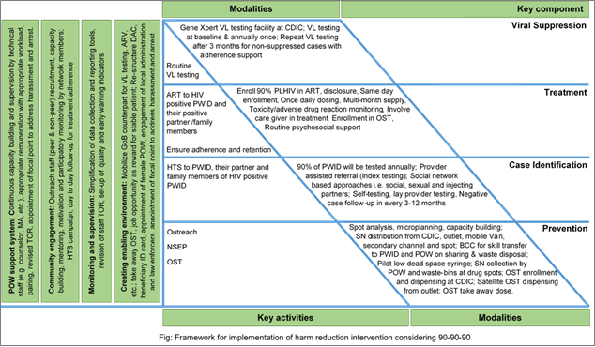
To avert the epidemic among PWID, harm reduction intervention has been re-strategized considering the 90-90-90 targets. The strategic framework is described in figure below –

The following initiatives will be taken as part of the grant:

Peer Outreach Worker deployment and training: POW will be viewed more professionally with a clear vision on professional growth. Their job description will be reviewed and updated; POW and non-POW will be recruited from a pool based on predetermined recruitment criteria and the PWID network will be more actively engaged in the process. At the most vulnerable locations of Dhaka (A1), 1:1 pairing of peer and non-peer outreach workers will be deployed to assume shared responsibilities Better remuneration is planned to uphold their morale, considering national standards. Outreach activities of POW will technically be supervised and mentored by Field Organizer, Medical Assistant and Counsellor. A detailed training plan will be rolled out. Before deployment in the field, each POW and non-POW will receive basic training followed by seven days’ placement in the field under the joint supervision of PWID network and designated staff of CDIC. The current Outreach training module will be revised by national and international experts and training will emphasize active participation and skill transfer.
Improve supervision of outreach workers to decrease the risk of diversion of needles and syringes: A routine surveillance system involving program, M&E and internal control personnel is in place and will continue to monitor any diversion of HIV commodities, i.e. Needle-Syringe, Condom, Medicines, etc. The ongoing initiatives to penalize those who are involved in these practices will be continued, strengthened and reinforced. Moreover, communication will be enhanced towards local pharmacies and diagnostic centres to prevent them from buying needle and syringes from the respective outreach staff.
Develop systems to distribute needles and syringes at times and places when and where they are most needed: 24/7 availability of syringes and needles, especially in early morning, late night and other off-hours, will be ensured through a duty roster among POW and peer volunteers. In addition to primary distribution channels of needle syringes in the spot through POW (50%), secondary channels (10% by pharmacy, grocery shop, rag pick shop etc.) and fixed facilities (20% by CDIC, DIC and outlet) will be utilized, following a pre-determined plan. The use of vending machines and mobile vans (15%) will be piloted to reduce the distribution loads on POW.
Improve collection and disposal of used needles and syringes to decrease the risks of reselling and reusing needles and syringes: There will be an SOP for the collection and disposal of the needle-syringe and other medical waste. Emphasis will be placed for continuous orientation of POW, non-POW, volunteer, PWID and people around drug trade on safe injection practice and safe disposal. Similarly, routine campaigns (quarterly) around drug spots will be organized on safe injection and safe disposal. Items for aseptic precautions, such as utility gloves, forceps and puncture-proof bags, will be supplied. In addition, waste-bins and collection boxes will be placed at drug spots, and with the people around the drug trade (e.g. pushers and peddlers).
Improve monitoring and evaluation tools for accurate data collection, analysis and use.
For M&E data collection, monitoring, reporting and further use in decision making, a set of simplified and effective tools will be developed for use in the new grant. The number of forms/formats/tools and number of variables in each tool will be reduced to a more feasible level, especially for POW. Thus, the existing M&E framework will be further revised and simplified to make each of the cadres accountable. Training on data analysis and its use will be organized and continuous data use will be conducted.

Response to TRP recommendations on Oral substitution treatment programme:
Besides NESP, special emphasis will be given to the quality, staff capacity and clinical issues related to the OST which includes -
Decrease loss-to-follow-up in the OST program: Regular follow-up for mental health support, adherence and retention will be done by clinical psychologists, following an appointment schedule. A technical committee at the CDIC has already been formed to use the updated mother-list for client selection for OST using agreed eligibility criteria [i.e. >18 years of age, injecting for >1 years, H/O drug treatment (willingness to stop using drugs), HIV and or HCV positive, etc.] and to evaluate clients’ adherence and make treatment decisions. Before enrolment in OST program, the psychologist will check clients’ willingness and readiness following a predefined scale [circumstances, motivation, and readiness scales (CMRS)]. A separate scale [clinical opiate withdrawal scale (COWS) is in place to support OST induction and maintenance. Larger take home/away supplies of methadone have been provided to PWID considering the COVID-19 situation and to reduce loss-to-follow-up. Provision for take away/home dosage as retention and adherence reward have also been introduced. Simultaneously, satellite OST dispensing corner will be installed in outlets and spots after completing pilots in the current grant. Stable OST clients, i.e. those who have been on treatment for more than one year and have >90% adherence, will have an appointment every 3-6 months; the rest will have more frequent visits. Newly enrolled clients will have twice weekly to monthly appointments based on their length of treatment. Special attention will be devoted to maintaining optimum methadone dose considering co-administered drugs and their interactions. Special attention will be devoted to maintaining optimum methadone dose considering co-administered drugs and their interactions.
Use OST retention as a success marker of the programme: The program will set OST retention as quality indicator to bring quality in the program which will be reported during PUDR submission.
Increase oral substitution treatment coverage among women through development of gender responsive services: In line with gaps found in recent studies, more priority will be placed on enrolling HIV positive PWID and WWID in OST; in order to achieve this female POW will be stationed in each of the facilities (i.e. CIDC, OST centre, and Outlet) of Dhaka, Gazipur, Narayangonj, Cumilla and Rajshahi. POW under the FSW intervention of PR Save the Children will be trained on dealing with drug related issues including OST to ensure services for WWID who are involved in the sex trade. FSW DICs of those districts will link WWID to CDICs (of PWID intervention) for OST and ART. WWID will have access to both FSW and PWID DIC/CDIC/Outlet to avail OST services. The uptake of OST among WWID will be monitored through gender segregated reporting.
increase availability of psychosocial support: (see also above under ‘reducing loss to follow up in OST program) the program will appoint clinical psychologists as counsellors in addition to qualified physicians, nurses and POW for ensuring continuous psychosocial support to OST clients with an eye on improving retention and adherence.
Enhance knowledge about oral substitution treatment programme standards both at policy and operational levels: Three tier capacity building, i.e. written guidance note, virtual/physical training sessions and hands-on orientation will be continued to capacitate staff on OST. Each CDIC will organize quarterly orientation sessions and sensitization meetings at their catchment areas to enhance knowledge of the local law enforcers on drug, drug use, OST, criminal justice system and HIV.
As applicable, please list the sections and attachments modified in the funding request, and new supporting documentation provided:

Issue 3: Deficiencies in addressing the legal environment and gender considerations for people who use drug
TRP Input and Requested Actions
Issue: Despite the existing laws that criminalise drug use, harm reduction has been implemented at a large scale in the capital (Dhaka) and increasingly in other cities. The legal environment in Bangladesh has, however, become increasingly unfavourable for effective programming for people who inject drugs (PWID), including the introduction of the death penalty for methamphetamines in the 2018 Narcotics Control Act. A joint Global Fund / UNODC (2020) mission report notes a 340% increase in HIV prevalence among PWID over the past decade and focuses on eight key areas in need of reconfiguration in order to ensure program feasibility and quality, including through the engagement of law enforcement in the harm reduction programme and utilizing opportunities to introduce preventive services in prison and other closed settings.

Action: In the revised funding request, the TRP requests the applicant to reconceptualize its program to promote an enabling environment, in which program target populations can access evidence-based, tailored, quality interventions. Activities in a module to address the adverse legal environment in Bangladesh should be developed based on recommendations from the Global Fund / UNODC mission report and have not been included in the funding request. These include:

1) Dedicated funding for the development of a training curriculum for police on HIV and key populations, that will be incorporated into National Police Trainings.

2) Identifying and addressing gender-specific barriers and developing a tailored set of prevention and care interventions for women who inject drugs, female and transgender partners of sexual partners of male drug users, and transgender people who use drugs.

3) Providing a proposed set of interventions to scale up HIV/TB services among people in prisons and other closed settings.

4) Providing guidance for action in the event that a peer outreach worker is arrested.

Please provide an executive summary of the actions taken:
Action 1

The program has been reconceptualized, and strengthening the enabling environment and capacity building have become separate programmatic objectives. A National Working Group on Drug Policy and Harm Reduction will be formed to provide overall guidance and strategic direction to undertake specific actions to improve the enabling environment. UNODC Bangladesh office will be supporting the Government of Bangladesh in leading the process of developing a National Training Curriculum for Police and Law Enforcement Officers, as suggested, in coordination and collaboration with other UN bodies such as UNAIDS, key civil society organizations, community-based stakeholders, networks and existing forums such as the Law Enforcement and HIV Network (LEAHN). A National Working Group will oversee the development of the curriculum, and once it has been completed it will be piloted and fine-tuned. Then, it will be implemented; training workshops will be organized as a joint initiative with the Ministry of Health and Family Welfare and Ministry of Home Affairs. UNODC will spend its own funds to develop the training module (by December 2020); the curriculum will be integrated into police training academies both for pre- and in-service training. Funding for the actual training of trainers and trainings of police and law enforcement staff is not yet confirmed at this stage.
Based on the developed training module, TOT will be imparted by ASP and few beaches training will be conducted under this proposed grant in collaboration with Bangladesh Police signing a MOU.

Action 2
PR-SCI plans to recruit female Peer Outreach Workers (POW) in each facility type (i.e. CDIC, OST centre, DIC and Outlet) to enable and enhance access by WWID and female/transgender partners of male PWID to harm reduction services and HTS. In three selected districts, including Dhaka and two adjacent districts (i.e. Gazipur and Narayangonj), POW under the FSW intervention will also receive training on dealing with drug-related issues and needle and syringe exchange (NSE). This will help ensure necessary services for WWID involved in transactional sex. FSW DICs in those districts will have provisions for NSEP and linkages with CDICs/OST centres (of PWID intervention) for OST and ART. WWID will have access to both FSW and PWID DIC/CDIC/OST centre/Outlet for availing services. Referral linkages will be developed with PR icddr,b’s DICs in the respective areas who are providing HIV services to transgender women through the Global Fund supported project. To avoid duplication, recording and reporting will be coordinated among PRs and SRs/SSRs.

Action 3
The National Tuberculosis Programme (NTP) and its implementing partners have been providing TB services in 68 prisons since 2014. This platform will also be utilized to render HIV services. Under the leadership of National Working Group, a coordinated effort will be made between ASP, NTP, UNODC and Save the Children attempting to scale-up HIV/TB services in prison and other closed settings in Bangladesh. The programme will follow set guidelines and protocol for prison intervention, originally developed by UNODC for its member states. The intervention at the prison setting includes establishing a national technical working group on HIV and TB consisting of officials from both Home and Health Ministries, and an assessment to identify the needs, challenges and opportunities in developing and implementing HIV intervention programs in prisons. UNODC/UNAIDS will mobilize resources to provide the required technical assistance.
Advocacy workshops at the national level to sensitize key stakeholders on harm reduction and human rights pertaining to HIV interventions in prisons will be conducted, and capacity building of NTP partners and health staff in persons to deliver the HIV services in the selected prisons. This initiative will be orchestrated by ASP. There will be provision of combined HIV/TB messages, HTS, and HIV screening for TB patients and other high-risk groups in prisons and through mobile vans, ARV and OST dispensing among prisoners. This will be done by ASP in collaboration with NTP, Save the Children and its SRs. Dialogue regarding the next steps will be initiated, such as establishing a strategic information system on the epidemiological situation, behavioural factors, modes of transmission, availability, quality and coverage of relevant healthcare services in prisons.

Action 4
A strong law enforcement involvement in the harm reduction program is essential to reduce harassment, including arrests of POW and/or PWID. Save the Children recently has prepared reports on ‘’Review of Legal Policy Environment’’ [33] and ‘’Situation Assessment on the Impact of Legal Policy Environment Over the Harm Reduction Intervention for PWID in Bangladesh’’ [34]. The findings and recommendations made in these reports reinforced the engagement of policy makers and law enforcers in a systematic way.

Beyond the high-level advocacy meetings that will be organized to create understanding and support for the program, including with the Prime Minister’s Office, facilitated by high-level UN officials, and the establishment of a working group on drug policy and harm reduction, at the local level there will be engagement of KP communities and networks, in advocacy sessions with local leaders and law enforcement members in order to mitigate harassment of POW. Investing in orientation and sensitization for law enforcers (i.e. local police, RAB and DNC officials) on HIV and harm reduction program in all harm reduction sites.

Focal points will be appointed at SR/SSRs level to address arrest of POW, ID cards will be issued for each POW that are jointly signed by Ministry of Health and Family Welfare and Ministry of Home Affairs. Service access cards will be issued for PWID, especially for OST clients / HIV positive PWID. A hotline will be set up so that field-based staff can get instant response and support from the management team in case a peer outreach worker is arrested.
As applicable, please list the sections and attachments modified in the funding request, and new supporting documentation provided: Two recent additional assessment study reports have been added: Save the Children, “’Review of Legal Policy Environment”, July 2020 and Save the Children, ’Situation Assessment on the Impact of Legal Policy Environment Over the Harm Reduction Intervention for PWID in Bangladesh’’, July 2020, and have been added as reference #33 and #34 to the updated FR request document.

Issue 4: Lack of comprehensive planning to mitigate risks in the proposed changes in implementation arrangements
TRP Input and Requested Actions
Issue: The funding request proposes significant changes to the service delivery model and the roles of the three Principal Recipients (PRs). The National AIDS / STI Programme of the Ministry of Health and Family Welfare (NASP) will take on increased responsibility for HIV service delivery, including integration of HIV services with sexual and reproductive health (SRH), and maternal, new-born and child health (MNCH) at public hospitals and direct contracting of community health workers / outreach workers to deliver HIV services to KP. NASP will additionally take the lead in the health product management system, including procurement of condoms, needles, syringes, opioid substitution therapy (OST) drugs and antiretroviral drugs (ARVs) from government’s operational budget.

The TRP applauds the Government’s commitment to extend its role and leadership in the HIV response with potential opportunities for integration with other services and reduction in costs. However, the funding request acknowledges that the infrastructure and staffing in government facilities do not always enable the provision of quality care, citing shortages of relevant skills and frequent transfers of the government trained service providers. Some studies have also shown that KP are unwilling to visit public healthcare facilities for sexually transmitted infection (STI) services due to concerns about discrimination or a lack of privacy. Thus, if these changes are not carefully planned and monitored, there are significant risks to programme delivery and previous investments. The funding request presents some description of changes in functions, but lacks an overall comprehensive plan that is aligned with the grant implementation.

Action: In the revised funding request, the TRP requests the applicant to outline plans to conduct the following critical analyses in the first year of grant implementation, which will inform subsequent decisions and plans to transfer responsibilities:

1) Assessments of the capacity of NASP, health facilities and community health workers to deliver their proposed roles, including the provision of differentiated services to KP; procuring health products; and providing oversight, supervision and technical assistance. These assessments should be led by the LFA and consider financial management capacity, human resources (skills and availability), information systems and include clear plans, timelines and budgets for capacity building and how it will be monitored.

2) A feasibility study of direct contracting of outreach workers vs. contracting community-based organizations (CBOs) with pre-existing relevant experience with KP, in order to measure the cost-effectiveness, quality, acceptability, workload impact and ability to achieve a standardized quality service package of both options before a decision on modality of contracting is made.

3) Consultation with all stakeholder groups, particularly the KP, to agree on the proposed implementation modalities, based on the findings of these assessments.

4) Based on the results of the analyses 1)-3), new roles for NASP should be piloted, with the other PRs providing technical assistance (TA) as needed. The learning from these pilots of the new NASP roles should then be used to prepare detailed plans for transfer of responsibilities, which would set out the timelines and budgets for a phased transition.

Once these analyses have been conducted, a staged implementation plan could be prepared, to include contingency plans to mitigate risks, in case new systems do not function well (such as maintaining a buffer amount in the grant for procurement to ensure that services are not interrupted) and ensuring government-led services are acceptable to KP and are able to ensure outreach to achieve intended scale and coverage.
Please provide an executive summary of the actions taken:
Issue 4: Lack of comprehensive planning to mitigate risks in the proposed changes in implementation arrangements

ASP Response:

ASP will pilot playing the role of implementer of prevention, testing and treatment of FSW and PWID in five selected public hospitals which have been providing ART and HTS services since 2017. These tertiary public hospitals will act as HIV programme hub for the respective districts. PLHIV, including all groups of key populations, are receiving ARV drugs, counselling, condoms (if required), and follow-up services from the ART centre in an environment free of stigma and discrimination. HTS has been conducted regularly for the all populations, including KPs, and HIV positive cases are referred to ART centres. These hospitals are gradually becoming more capacitated to deal with KP and other marginalized populations. This process will be carefully documented as part of a feasibility and acceptability study (see below).

ASP initiated implementation of PMTCT services in public hospitals since 2013 as geographical priority approach and currently having interventions in twelve tertiary public hospitals in seven districts. The PMTCT initiatives are technically and financially supported by UNICEF Bangladesh. Hospital management deployed physicians from the gynaecology and paediatrics department to oversee the programme. Dedicated staff were also recruited including MT lab, counsellor and peer counsellor. Approximately 80% of the ANC cases were screened for HIV and syphilis. Hospital management constituted a technical committee to oversee the intervention.

Strengths of the implementation of KP services by ASP
In the 3rd health sector programme, ASP has implemented the HIV prevention and treatment programme for KPs by procuring NGO services. Different national NGOs and CBOs implemented KPs (PWID, FSW, MSM/TG) targeted prevention programme across the country. ASP had the overall management responsibilities and played an active role in oversight and technical support for quality assurance of the programme. Since 2017, ASP took over the responsibility of management of ART services which are delivered through public healthcare facilities. ART enrolment has been significantly increased in the hospital compared to previous years managed by NGOs.
A dedicated Deputy Programme Manager led the M&E team of ASP for regular monitoring, quality assurance and troubleshooting for improving the quality in line with its M&E plan. ASP is conducting regular field visits, following a standard checklist and ensuring data quality through various methods. Joint initiatives are also undertaken by ASP to improve the quality of the programme in collaboration with NGO PRs, UN agency, INGO, CBOs. ASP also led the technical forum of HIV clinicians.
Proposed Programme under GF
Based on past experience of managing NGO run KP intervention, ART/HTS centres management and PMTCT interventions, ASP proposes to implement an HIV prevention programme for KPs, especially PWID and FSW, through five public healthcare facilities by recruiting selected HR and covering the operating costs under the coming grant. Under this grant, a full-time medical officer cum manager, outreach supervisors and peer educators will be recruited while an MT Lab and counsellor have already been recruited funded by the government’s OP fund; these new staff will be engaged in the intervention. In addition, other staff of the ART/ HTS/ PMTCT centres will provide synergistic support to the KP service delivery points.

An organogram is attached at the end of this write-up.

A package of comprehensive services, including STI and abscess management, condom promotion, NSEP, HTS, and BCC will be offered, and linkages to hospitals will be available for other health services.

Health products for KP such as condoms, needles and syringes, and STI drugs will be provided by the OP fund. HTS will also be administered through the attached HTS centres under the support of the government fund. Only establishment costs, physical infrastructure and monthly operation cost will be covered under the GF grant. 3000 PWID and 1250 FSW will be reached with services under the grant implemented by ASP, implemented in the 3rd and 4th quarter of 2021, after the proposed feasibility study has been completed and recommendations from it have been followed up upon. The unit cost per PWID will be USD 69 and FSW USD 12, in comparison to the existing unit cost as per NSP of USD 95 and USD 88, respectively.

Steps to be taken based on TRP recommendation:

Action 1
Assessments of the capacity of NASP, health facilities and community health workers to deliver their proposed roles, including the provision of differentiated services to KP; procuring health products; and providing oversight, supervision and technical assistance. These assessments should be led by the LFA and consider financial management capacity, human resources (skills and availability), information systems and include clear plans, timelines and budgets for capacity building and how it will be monitored.

ASP Response
ASP will provide support to conduct a capacity assessment by the local funding agency (LFA) in terms of oversight, procurement, HR experience, financial management capacity of ASP, provision of differentiated service to KP by the selected health facilities and community workers. As per needs of the LFA, ASP will ensure all forms of support. The detailed plan is attached.

Action 2
A feasibility study of direct contracting of outreach workers vs. contracting community-based organizations (CBOs) with pre-existing relevant experience with KP, in order to measure the cost-effectiveness, quality, acceptability, workload impact and ability to achieve a standardized quality service package of both options before a decision on modality of contracting is made.

ASP response
A feasibility study will be conducted to assess the direct contracting of outreach workers versus contracting community-based organizations (CBOs) which have pre-existing relevant experience with KPs. This study is aimed to measure the cost-effectiveness, quality, acceptability, workload impact and ability to achieve a standardized quality service package consisting of both options before finally deciding the contracting modality. The study may be conducted by an individual consultant from December, 2020 to February 2021 (3 months) within the extension period. A TOR will be developed with detailed tasks and assignments for hiring the consultant and a core team will be formed to support consultant work. A dissemination session will be facilitated with relevant stakeholders, especially considering the inputs of KPs, in order to finalize the report. Based on the report findings, ASP will decide the subsequent intervention steps. The cost of the study is budgeted in this grant. The Table 1 below describes detail time-line for the planned activities that would be completed within six months of the first year of the grant cycle.

Action 3
Consultation with all stakeholder groups, particularly the KP, to agree on the proposed implementation modalities, based on the findings of these assessments.

ASP response
Several sessions of dialogue will be conducted with KP to understand their willingness and recommendations to uptake services from hospital, and sessions will be conducted by consultant, seeking assistance from KP networks. The dialogue will be in Dhaka and major cities. Around 15 KPs will attend each session, and an enabling environment will be constructed so that KPs can non-hesitantly express their opinions. These sessions will also constitute part of the assessment.
To promote an enabling environment, greater understanding of KP, and assure readiness of service delivery points ASP will conduct meetings/workshops at those selected hospitals with hospital departments, existing ART/ HTS/ PMTCT programme, which will also be attended by DNC, law enforcement agencies, NGO PRs, and local CBOs. A solid referral link will be established within the hospital system with skin/ VD, medicine, Gyne and relevant divisions to ensure comprehensive health services will be available for KP.

Action 4
Based on the results of the analyses 1)-3), new roles for NASP should be piloted, with the other PRs providing technical assistance (TA) as needed. The learning from these pilots of the new NASP roles should then be used to prepare detailed plans for transfer of responsibilities, which would set out the timelines and budgets for a phased transition.

ASP response
In conjunction with these initiatives, ASP will initiate staff recruitment for the programme except for peer educator/ outreach workers, which will be conducted based on assessment recommendations. It is vital for staff to have expertise in KP programmes. Besides this, regular sessions will have to be organized within the HIV PRs to share experiences and lessons learned from KP interventions, challenges and ways forward. Expertise will be shared among the PRs in order to improve the implementation arrangement of ASP. Logistics and commodities (condom, syringe, STI drugs etc.) will be available at the five hospitals by June, 2021 with support from the OP.

Nevertheless, there remain a few existing challenges in the intervention of KP implementations under ASP system. For example, there are challenges in the supplies of commodities, creating an enabling environment for KPs, etc. Since 2012, ASP has been procuring health products through Central Medical Storage Depot (CMSD). Within their eight years experiences, there were two procurement delays in providing planned items during country crisis situations, despite having sufficient stocks of health products with faraway expiration dates. To ensure uninterrupted supplies and mitigate other challenges arising during the implementation period, ASP kept its budget under contingency plan. In this context, at least three (3) months’ worth of supplies will be ensured with the contingency budget for years 2 and 3. Table-3 shows the planning of ASP to direct implementation.

Table-3: A Gantt Chart showing overall planning of ASP in moving to direct implementation

SL | Activity | Nov-20 | Dec-20 | Jan-21 | Feb-21 | Mar-21 | Apl-21 | May-21 | Jun-21 | Jul 21 | Aug 21 | Oct-21
1 | Assessment of the Capacity of ASP
2 | Feasibility study of direct contacting of outreach or CBO
3 | Dissemination and session with KPs/ Consultation with KPs
4 | Recruitment/renovation of the facility/ preparation
5 | Supply of the service logistics from OP fund
6 | Piloting the programme in 3 public hospital
7 | Service uptake rest 2 hospital

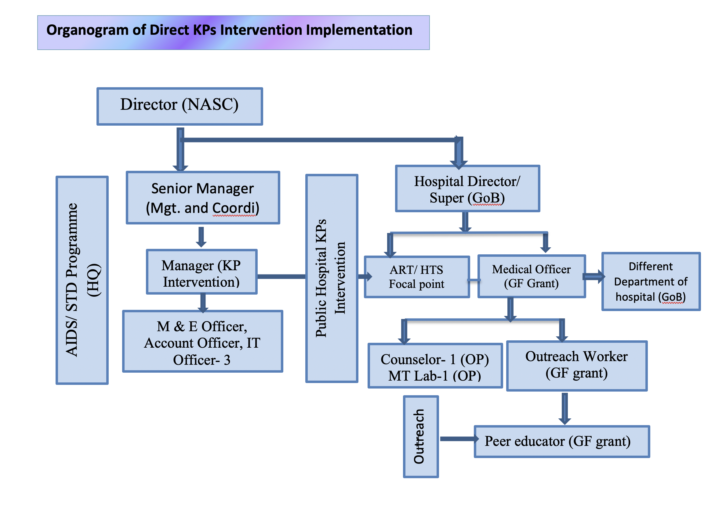
As applicable, please list the sections and attachments modified in the funding request, and new supporting documentation provided:

Issue 5: No mention of HIV programming for Rohingya Refugees (Forcibly Displaced Myanmar National – FDMN) in Cox’s Bazaar
TRP Input and Requested Actions
Issue: The NSP states that among the 919 new HIV cases reported in 2019, 11% (105) were among Rohingya refugees (FDMN) in Cox’s Bazaar. It also notes that children of displaced persons and some minority ethnic populations groups are suspected to face higher HIV vulnerability. Furthermore, the NSP notes that spouses of refugees, internally displaced persons, and minority ethnic populations may have a heightened vulnerability due to casual sex work and a very low level of awareness of safe sex (NSP pp. 88-89).

Over the period of 2013 – 2020, the Government of Bangladesh with funding support from UNICEF has been supporting prevention of mother-to-child transmission (PMTCT) at district and upazila levels in Sylhet and Cox’s Bazar, through an integrated approach and a special focus on migrants. The TRP is concerned that the UNICEF support is ending in 2020 and no interventions have been proposed for this population in the NSP nor the funding request. The non-inclusion of specific activities for this population is a missed opportunity to mobilize funding above allocation.

Action: The TRP recommends the applicant to continue seeking complementarity with other implementing partners, in order to ensure HIV prevention, case detection, diagnosis, treatment and care, and to support activities to this uniquely vulnerable but accessible population under the funding request. The TRP also requests the applicant to liaise with humanitarian actors working in the refugee camps to incorporate interventions to address the health needs, including HIV and TB services among the Rohingya refugees in the revised funding request.
Please provide an executive summary of the actions taken:
Since August 2017, at least 745,000 Rohingya refugees were forcibly displaced into Cox’s Bazar, Bangladesh, in the hope of fleeing unprecedented violence and human rights violations in the Northern Rakhine state of Myanmar. These new arrivals have joined other Rohingya refugees who escaped from Myanmar during previous waves of violence dating back to as far as 1978. As of December 2019, approximately 1.1 million Rohingya are seeking asylum in the Cox’s Bazar district, predominantly in the Teknaf and Ukhiya upazilas. The Rohingya refugees have now become part of the host community, consisting of an estimated total of 335,900 people (ISCG 2019).

In response to their recognized needs during the onset of the crisis, ASP formulated the “Response in HIV Prevention in Cox’s Bazar Benefiting Refugees, Forcibly Displaced Myanmar Nationals and Host Communities: A multi-sector coordinated framework of action” in November 2017. Considering the evolving situation and needs, the strategic framework was revised in December 2019 in an effort to strengthen coordination, delivery and implementation of HIV and AIDS prevention and management services to the host community and to Rohingya refugees. In favour of ASP, District Health Manager (Civil Surgeon) helped systematize this response to mobilize and coordinate the HIV prevention and treatment response. Ongoing activities, which pursue the framework pillars of the HIV and AIDS response, are depicted in the following Table:

Table: List of ongoing activities in the field of HIV and AIDS with FDMN population
Service | Implementing agency | Activity | Remarks
HIV prevention | IOM | Five camp-based primary health care centres to provide IEC/BCC prevention messages to general population | IOM support will continue until June, 2022
 | Light House | HIV prevention services for FSW from both host and FDMN communities, including prevention messages, BCC, promotion and distribution of condoms, STI management, counselling and HIV testing via two DICs (one in Sadar and another in Ukhiya), supported by GF under PR SCI and UNHCR/UNFPA | - GF support will continue until 2023.  - The UNHCR support will continue until December 2020, with yearly extension.
 | MSF, Red Crescent Society, Malaysian Field Hospital, Hope Foundation, ACLAB, Friendship, YPSA, Dhaka Ahsania Mission, Sajida foundation. Mukti, Nongor, RTM Intl, PHD | Awareness messages pertaining to HIV were integrated into mainstream health and SRH activities by various international and national NGOs for FDMN population in camp areas. All of these organizations are providing basic HIV prevention messages through their existing services, among which MSF and Red Crescent hospital also provide additional support for HTS and treatment. Programs have different durations. | - Important to note that HIV prevention messages were mainstreamed in to SRH and MNCH IEC activities, so in future it will continue to have HIV IEC component.
 | Bandhu Social Welfare Society, Sub-recipient of PR-icddr,b and from UNFPA and USAID | HIV prevention services for MSM and hijra (host and FDMN), including HIV prevention messages, BCC, promotion and distribution of condoms and lubricants, STI management, counselling and HIV testing and linkage to care and treatment services, and TB screening and referral from one DIC supported by the GF.  Two-wellness centres were established by BSWS, with funding from UNFPA and USAID, who also work with MSM and hijra (host and FDMN) situated in Kutupalong. | - GF support will continue until 2023.
 | Government and UNICEF | From December 2018, PMTCT services were initiated in Cox’s Bazar District Sadar Hospital, Ukhiya Upazila Health Complex and 15 selected health facilities in camp sites run by different international and local agencies. Both the host and FDMN populations are able to access the services. | - GoB supplies free ARTs for FDMN and Host communities  - UNICEF-GoB PMTCT initiative will continue until 2022. The camp-based organizations are supported by different agencies
 | UNFPA, HOPE, Mukti, RTM, Light House, Bandhu Social Welfare Society | UNFPA is supporting management of STI/RTI, family planning, protection against gender-based violence for the FDMN through local NGOs. BSWS is exclusively working for the MSM/MSW and TG populations among the FDMN. | - Current UNFPA support will continue till December 2020
Case detection and diagnosis | Cox’s Bazar District Sadar Hospital, Ukhiya Upazila Health Complex | ASP supplies testing kits procured with government funds. WHO and UNICEF supports emergency stock out situations.. The HTS centre is backed up by the ART centre. | This will continue until the end of the current OP period (2022)
 | International Organization of Migration (IOM) (3 facilities) | Three HTS centres were set up at three Primary Health Care Centres at camp sites (2 in Ukhiya, one in Teknaf). These centres are also administering PMTCT services. | This will be continued until 2022. (attachment 2)
 | MSF (4 sites), Partners in Health and Development (5), Research, Training and Management International (3), Friendship Bangladesh (1), Relief Int. (1) | HIV testing is performed and HIV positive cases are referred to the government healthcare facilities for ART enrolment. | - MSF will continue until 2023  - RTM and PHD will end in 2021.
 | BRAC (15 sites) | In collaboration with NTP and ASP, BRAC is conducting HIV testing for TB patients (attachment 3) and other high-risk populations. The HIV positive cases will be referred to ART centres for confirmatory tests and ART initiation | - To be continued until 2020. Afterwards, ASP will provide HIV testing kits for screening of TB and other high-risk populations
Treatment and care | Government, IOM, WHO, UNICEF, Ashar Alo Society (AAS) [Sub-recipient of the PR Save the Children] | ART and ART refill centres were established at Cox’s Bazar District Hospital and Ukhiya Upazila Health Complex (UUHC) and are accessed by both host and FDMN communities. UUHC is proximal to the campsites. Stable patients are referred to Ukhiya Health Complex.  ARV drugs are procured by government funds. IOM, WHO and UNICEF are also supporting ARV drug procurement during emergency stock-outs.  Under the Global Fund grant, Community Peer Counsellors (CPC) were also deployed by AAS at ART and ART refill centres in Cox’s Bazar and Ukhiya for ensuring patient navigation, peer counselling for disclosure and adherence, and the tracking of lost to follow-up cases. | - GoB/ASP support will continue as they are mainstreamed in to revenue/OP for manpower and procurement of drugs.  - GF supported community-based components will be continued until November 2020. However, in NFM 3 this community-based component was proposed .
SRH and Protection of Gender Based Violence | UNFPA, Light House | NGOs are administering comprehensive SRH services for FSW among the FDMN population through static service delivery points as well as outreach. GBV and sexual violence cases are referred to the relevant departments for health, psychosocial and legal support. Light House also runs a shelter home for survivors of GBV, and street-based violence, which is situated in Cox’s Bazar Sadar. | - UNFPA supported current contract will end in December, 2020, discussions are going on for extensions (attachment 5)

Proposed activities in the revised funding request
- Support for regular district level biannual coordination and advocacy sessions with all of the relevant stakeholders
- Support for training and capacity building (for HTS) for implementing agencies providing health services in the FDMN camp for quality assurance
- Ensuring uninterrupted supplies of HIV testing kits

ASP along with stakeholders will review the strategic framework 2019 will do a gap analysis. Based on the gap analysis, a few interventions will be proposed in the GF grant under PAAR.

As applicable, please list the sections and attachments modified in the funding request, and new supporting documentation provided:

Issue 6: Lack of Financial Sustainability Planning
TRP Input and Requested Actions
Issue: The HIV program faces a very large financing gap of 80% for the 2021-2023 budget period. Domestic resource allocation remains low, showing a slight increase from 7% to 9% of the HIV budget, with the Global Fund to cover 10% and an additional 1% coming from United Nations agencies. Although the HIV program recognizes the need to consolidate government funding and maximize the utilization of existing resources more efficiently, the funding scenario at present continues to hamper the program’s ability to reverse prevalence trends among KPs and will not allow the scale-up needed to control the epidemic by 2030. Public expenditure on health remains low overall, and there is very high reliance on out-of-pocket spending. The 4th Health Population Nutrition Sector Program 2017-2022 (HNPSP) which funds the HIV program is coming to an end in 2022, and with it the support of the current Sector Wide Approach, but the funding landscape shows no additional domestic public or private sector contributions, or other potential major financing options to the HNPSP.

There is currently little clarity on how the National Strategic Plan for HIV and AIDS Response plans to reach financial sustainability to ensure the continuation of interventions in the run-up to the 2030 goal of ending the epidemic.

Action: In the revised funding request, the TRP suggests that the applicant:

1) Undertakes a detailed budget review to focus on a limited number of the highest priority interventions in order to support the scale-up of selected prevention and treatment interventions as described in the HIV NSP.

2) Streamlines the allocation of resources to increase the value for money. In developing the more finely tuned and focused budget, the applicant is encouraged to seek efficiency gains as a means to extracting more value for money from available resources, especially those derived from reducing duplication or through integrating service activities where possible.

3) Presents a timeline for developing a financial sustainability plan during grant implementation. The financial sustainability plan should include the different potential sources of raising resources for the HIV Program domestically, and ensure high-level political commitment (be endorsed by the responsible entities) to the domestic resource mobilization plan to sustain the country’s effort to end the epidemic.
Please provide an executive summary of the actions taken:
TRP issue-6

Action 1: Undertakes a detailed budget review to focus on a limited number of the highest priority interventions in order to support the scale-up of selected prevention and treatment interventions as described in the HIV NSP.

Action 2: Streamline the allocation of resources to increase the value for money. In developing the more finely tuned and focused budget, the applicant is encouraged to seek efficiency gains as a means to extracting more value for money from available resources, especially those derived from reducing duplication or through integrating service activities where possible.

Response:
As suggested by the TRP, all PRs have undertaken a detailed budget analysis, and reviewed the budget line-by-line to identify areas to fine-tune and reduce non-priority areas, and re-allocate funds to the highest priority interventions. Thus, the three PRs have utilized funds to increase coverage of their interventions, attempting to minimize duplication and integrating activities where possible, leveraging each others’ expertise to optimize value for money and aid effectiveness. The target for reaching PWID has been increased from 13,600 to 17,035 (3,435, 25.26%) and for FSW from 31,140 to 31,250 (110, 0.35%). The target for OST has also increased from 3,200 to 3,500 (300, 9.38%). The targets for HTS increased among MSM from 24,375 to 29,250 (4,875, an 20% increase), hijra from 3,750 to 4,500 (750, 20%), PWID from 10,350 to 15,332 (4,982, 31.18%) and FSW from 27,000 to 28,125 (1,125, 4.17%). The target for ART adherence among PWID increased from 1,160 to 1,238 (6.72%).

The PR Save the Children has explored the cost-efficiency of both the program and management components, and with the gained efficiencies, harm reduction service provisions have been planned for 14,035 PWID, significantly higher than the previously proposed target of 11,500. The HTS target among PWID has also been increased to maintain the goal of achieving 90% testing per annum, with biannual testing. Similarly, the target for ART enrolment, follow-up and retention has been increased to 1,238 from 1,160, keeping in mind the prevalence data from IBBS 2015-16. Provisions were also inaugurated to ensure routine viral load testing for HIV positive PWID and their HIV positive partners and family members. The PR SC created provisions for gender-sensitive prevention and care interventions (e.g. deployment of female POW in each CDIC and Outlet) for women who inject drugs, as well as female and transgender partners of men who use drugs. PR Save the Children also outlined activities to respond the legal barriers especially for PWID intervention where UNODC and UNAIDS will explore the opportunity to mobilize additional resources for joint response.

The PR ASP also reviewed the submitted budget and program, and they shifted the funds to more prioritized activities such as increasing the coverage of PWID prevention interventions from 2100 to 3000. In addition, expanded HIV testing campaigns are also planned in non-intervention areas where approximately 935 tests will be conducted per year. Testing targets have increased from 80% to 90% among PWID. Practical implementation experiences for HIV testing and treatment within the public health facilities are guiding adjustments of the budget in order to optimize cost-efficiency and decrease of unit cost. Further, a few integral components have also been planned and budgeted such as functioning of the PLHIV database, development of the SOP for ART services including CD4 count and viral load optimization, TB and HIV service provision in the prisons, etc.

The PR icddr,b has also made efficiency gains from their existing budget and utilized the funds to increase HIV testing services (HTS) for MSM and hijra by 15% in order to attain to the expected and recommended level of 90% testing. icddr,b also has proposed to increase the coverage of Opioid Substitute Therapy (OST) for to 900 (350 in Dhaka and 550 in three priority districts). icddr,b will eventually shift their capacities to the government staff of the treatment centre of DNC so that OST services will be operated at the Government Drug Treatment Centres under DNC outside Dhaka. Ultimately, this will not only ensure sustainability but also enhance the government leadership in OST program in Bangladesh, leveraging resources from the Ministry of Home Affairs and Ministry of Health and Family Welfare for OST services, reducing donors’ dependence, by protecting rights of the marginalized populations.

To maximize value for money, several other issues need to be delineated. For example, the majority of the resource allocation for HIV prevention, care, treatment and support is based on geographical prioritization, thus increasing value for money since interventions are targeted and geographical prioritization could engender better impact, based on Investment case of the scenario 3. To enhance value for money, the Government revenue budget accounts for the time of selected National AIDS/STD Control staff, the office space used by the Government PR, utility-related expenditures, all costs associated with HTS and ART centres within public health facility premises, a considerable proportion of costs incurred for PMTCT, most procurement and supply costs of ARV drugs and methadone, and some costs pertaining to the procurement and supply of condoms and needles and syringes; STI drugs; HIV testing kit and viral Load cartridge. It is assumed that these will remain as sustainable functions, since they constitute an integral component of the Health Sector under full ownership of the Government. The government makes investments towards the HIV response, where 20% of the total HIV expenditure is from government sources. The government is also planning to contribute to intervention coverage for PWID through both its own funds and the Global Fund. This will further enhance their value for money as the existing government space and personnel will be leveraged to support the harm reduction interventions. CDICs will gradually been integrated with Government selected hospitals and comprehensive service will be provided for PWID with the view of transition and sustainability. In addition, OST is gradually being shifted to government premises through coordination efforts between the Department of Narcotics Control and the AIDS/STD Program. For FSWs, good portion of clinical services, STI, HTS, MNCH-FP has been planned to be delivered from government health facilities under MOHFW and also from the city corporation health facilities under local government. Thus, HIV interventions are gradually being integrated into the government infrastructures to support key populations. In addition, integration initiatives have been planned such as with the Communicable Disease Control, National TB Program, maternal and child health departments, etc. These options will be explored and deliberated in order to integrate HIV services with hepatitis, TB, ANC and SRHR. Other co-funding opportunities are also being strengthened, especially the engagement of UN agencies in advocacy initiatives, development of policy guidelines, health systems strengthening, and expansion of interventions in challenging situations such as in humanitarian and prison settings and among returnee migrants, etc.

As per investment case scenario 3, total resource need for 2021-2023 is USD 65.1 million. Whilst available resource for the period is UD 49.8 million. Of these. Global Fund will provide USD 23 million, USD 23.9 million is available from domestic resources and USD 2.84 million is available from UNICEF, UNFPA and UNAIDS. It indicates that overall resource gap for three years (2021-2023) is around 24%.

Action 3: Presents a timeline for developing a financial sustainability plan during grant implementation. The financial sustainability plan should include the different potential sources of raising resources for the HIV Program domestically, and ensure high-level political commitment (be endorsed by the responsible entities) to the domestic resource mobilization plan to sustain the country’s effort to end the epidemic.

Response:
Bangladesh has further reviewed the activities and costing components of the National Strategic Plan (NSP) of HIV which particularly prioritize emphasize the highest priority interventions based on country need. Conversely, the funding allocated for activities of lower priority has been reduced during this exercise. In this way, we have revised the coted National Strategic Plan (NSP) and the funding gap has been reduced significantly (Attachment Revised Costed NSP).

Various relevant ministries have already started investing in addressing HIV prevention, care and support. The Ministry of Health and Family Welfare (MOHFW) has already been investing resources for supplying health products/pharmaceuticals (e.g. condoms, needles and syringes, methadone) to KP interventions supported by the Global Fund. Since PWID are high priority KPs, AIDS/STD Program (ASP) has launched the procurement process to serve additional 10,000 PWID, and ART coverage will be expanded with the support from government revenue and OP resources under DGHS. Considering the importance of STI, ASP has initiated relevant management services via Upazila, District, and medical college hospitals across the country. Meanwhile, the ASP has procured STI drug and linkages with skin/ VD/ dermatology department for ensuring services for people affected by STI. The ASP is collaborating with NTP for HIV Testing and ART services, along with TB services, in selected prison settings.

Currently, the Ministry of Education is providing HIV prevention messages to approximately 40 million students every year. The Ministry of Expatriates' Welfare and Overseas Employment is providing training, encompassing HIV prevention topics to about one million people who are deployed for overseas employment each year. The Department of Narcotics Control (DNC) under Ministry of Home Affairs is offering their space for implementing OST program in their office premises in several locations.

During the COVID-19 situation, it would be difficult to obtain an even higher level of endorsement of financial commitment from various domestic sources. However, during the next Global Fund grant cycle implementation period, Bangladesh will develop a financial sustainability plan for HIV and AIDS Prevention and Treatment by 2022 by engaging key ministries, with an aim of achieving the 95:95:95 targets. As per TRP comments, this financial sustainability plan will reflect various domestic funding sources which are expected to be endorsed by the higher levels of the government as desired by the TRP.

As applicable, please list the sections and attachments modified in the funding request, and new supporting documentation provided:

Your response to the clarifications requested should be sent to the Fund Portfolio Manager

